To: All of our Valued ISIMET Customers
Subject: Effective February 1, 2021 ISIMET Price Increase

Due to the rising costs of raw materials, freight and labor costs, along with the increase in general business costs, effective February 1, 2021 ISIMET will increase prices on the following items:

All Controllers, S-Series and E-Series - average increase of 5%
Parts and Accessories - average increase of 8%

If you need assistance with a quotation, have questions or need additional information please contact ISIMET customer service at 866-897-0737, or your local ISIMET representative.

Happy Holidays and Happy New Year! We will be closed for the holidays on December 24 & 25 and January 1. We are looking forward to a great 2021, thank you for your business.

Sincerely,
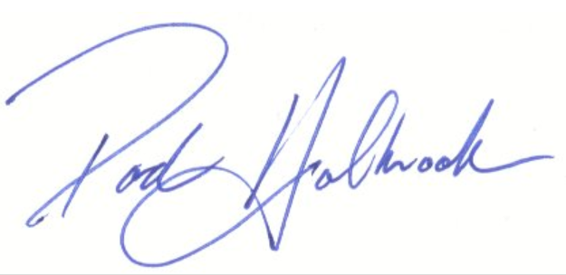
Rod Holbrook
ISIMET & MAPA Products

